Instructions for preparation of abstracts for ICPEAC 2017
second line if needed but restrict the title to 20 words
Author One* ¹, Author Two^{† 2}, and so on … use affiliation symbols *, †, ‡, §, ¶
* Research School of Physics, Australian National University, Canberra ACT 2601, Australia
† Department of Physics, Curtin University, WA 6845 Perth, Australia,
Synopsis Please replace this text with your synopsis. Keep it short, as it should not have more than 700 characters including spaces.

This is a sample abstract for ICPEAC 2017. Its overall layout is similar to that used for the previous ICPEAC meeting [1]. Preparation instructions are given below.
1. Abstracts should be written in English. The abstract should fit on one A4 page without the page number. The abstract should be submitted in PDF format through the conference web site. Files larger than 5 Mb will be rejected.
2. After submitting your abstract, you can examine how it will look online. It is your responsibility to check that the abstract is correctly formatted and readable. No changes to the submitted abstracts will be made by the conference organizers. Incorrectly formatted abstracts will be rejected.
3. Abstracts should be formatted for A4 size (210 x 297 mm, i.e., 8.268 x 11.693 inches). All text and figures must fit within top, bottom and side margins of 2 cm. Use 11 pt Roman font (LaTeX default) or a similar font such as Times New Roman throughout the abstract. This and other font sizes, as used in the Word template, are listed in Table 1.
Table 1. Font sizes to be used in the abstract.
 | Title | Synopsis | Body | Refs.
Size | 14 pt | 10 pt | 11 pt | 10 pt

4. The title should be typed in 14 pt boldface font and centered. If necessary, use a second line, single-spaced just below the first.
5. Leave 18 pt before the names of the authors (11 pt, bold) and again before the single-spaced affiliations and addresses (10 pt).
6. The abstract must have a short synopsis (at most 700 characters long) that is 16 cm wide. Use single-spaced lines with 10 pt Roman font for the synopsis. After 18 pt vertical spacing the body text is typed in two-column format with
0.75 cm column separation. The text should be single-spaced and the first line of each paragraph should be indented by 3 spaces.
7. Figures will be shown in colour in electronic versions of the abstracts. Give each figure a separate caption (10 pt) and, like a table caption, it should be concise (see Figure 1). If you choose to submit colour figures remember that most printouts from the web will be in black and white. It is your responsibility to ensure that the figures are easy to read and understand even in grayscale mode. When including figures, pay close attention to the file sizes, to avoid producing an oversized final PDF abstract file.
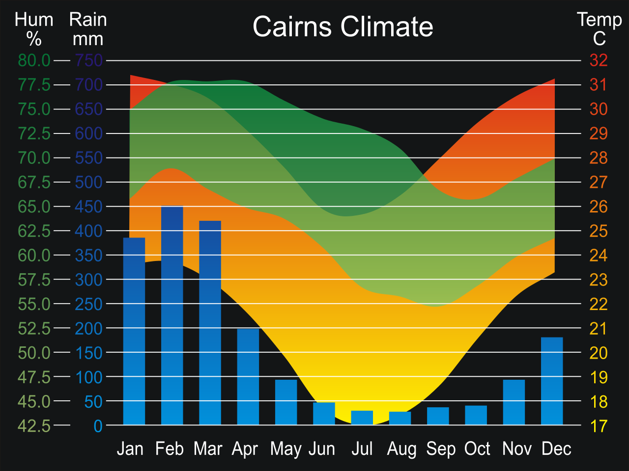
Figure 1. Humidity, rainfall and temperatures in Cairns, Queensland, Australia.
8. References in the text should be given by numbers in square brackets [1] (“Vancouver system”). The list of references in 10 pt font follows the last line of the text with one extra line inserted. Follow the style of the Institute of Physics, as used in Journal of Physics B.
References
[1] C. Díaz et al. 2015 J. Phys. Conf. Ser. 635 001001

¹ E-mail: Author.One@DomainOne.edu
² E-mail: Author.Two@DomainTwo.edu

